**МИНИСТЕРСТВО НАУКИ И ВЫСШЕГО ОБРАЗОВАНИЯ РОССИЙСКОЙ ФЕДЕРАЦИИ**

**ФЕДЕРАЛЬНОЕ ГОСУДАРСТВЕННОЕ БЮДЖЕТНОЕ ОБРАЗОВАТЕЛЬНОЕ УЧРЕЖДЕНИЕ ВЫСШЕГО ОБРАЗОВАНИЯ**

**КЕМЕРОВСКИЙ ГОСУДАРСТВЕННЫЙ УНИВЕРСИТЕТ**

**Институт Цифры**

**ОТЧЕТ**

**О ВЫПОЛНЕНИИ ЛАБОРАТОРНОЙ РАБОТЫ №6**

по дисциплине «Введение в нейронные сети»

студента 2 курса

**Лободы Максима Алексеевича**

Направление 02.03.02– «Фундаментальная информатика и информационные технологии»

Преподаватель:

ст. пр. Зимин А. И.

Работа защищена

«____________________»

“____” _____________2023 г.

Кемерово 2023

**Основная часть**

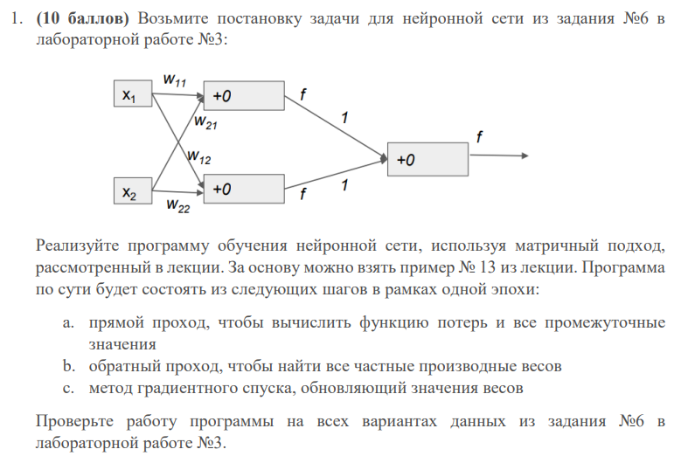

Код программы

from __future__ import annotations  
  
import numpy as np  
from numpy import ndarray  
from sklearn.datasets import make_regression  
from sklearn.linear_model import LinearRegression  
  
  
def mae(preds: ndarray, actuals: ndarray):  
 return np.mean(np.abs(preds - actuals))  
  
  
def rmse(preds: ndarray, actuals: ndarray):  
 return np.sqrt(np.mean(np.power(preds - actuals, 2)))  
  
  
def init_weights(input_size: int, hidden_size: int) -> dict[str, ndarray]:  
 weights: dict[str, ndarray] = {}  
 weights['W1'] = np.random.randn(input_size, hidden_size)  
 weights['B1'] = np.random.randn(1, hidden_size)  
 weights['W2'] = np.random.randn(hidden_size, 1)  
 weights['B2'] = np.random.randn(1, 1)  
 return weights  
  
  
Batch = tuple[ndarray, ndarray]  
  
  
def generate_batch(X: ndarray, y: ndarray, start: int = 0, batch_size: int = 10) -> Batch:  
 assert X.ndim == y.ndim == 2, "X and Y must be 2 dimensional"  
 if start + batch_size > X.shape[0]:  
 batch_size = X.shape[0] - start  
 X_batch, y_batch = X[start:start + batch_size], y[start:start + batch_size]  
 return X_batch, y_batch  
  
  
def permute_data(X: ndarray, y: ndarray):  
 perm = np.random.permutation(X.shape[0])  
 return X[perm], y[perm]  
  
  
def sigmoid(x: ndarray) -> ndarray:  
 return 1 / (1 + np.exp(-1.0 * x))  
  
  
def sigmoid_der(x: ndarray) -> ndarray:  
 return sigmoid(x) * (1 - sigmoid(x))  
  
  
def relu(data: ndarray) -> ndarray:  
 c = data.copy()  
 c[c <= 0] = 0  
 return c  
  
  
def relu_der(data: ndarray) -> ndarray:  
 c = data.copy()  
 c[c <= 0] = 0  
 c[c > 0] = 1  
 return c  
  
  
def activation(data: ndarray) -> ndarray:  
 return sigmoid(data)  
  
  
def activation_der(data: ndarray) -> ndarray:  
 return sigmoid_der(data)  
  
  
def forward_loss(X: ndarray, y: ndarray, weights: dict[str, ndarray]) -> tuple[ndarray, dict[str, ndarray]]:  
 M1 = np.dot(X, weights['W1'])  
 N1 = M1 + weights['B1']  
 O1 = activation(N1)  
 M2 = np.dot(O1, weights['W2'])  
 P = M2 + weights['B2']  
 loss = np.mean(np.power(y - P, 2))  
 forward_info: dict[str, ndarray] = {}  
 forward_info['X'] = X  
 forward_info['M1'] = M1  
 forward_info['N1'] = N1  
 forward_info['O1'] = O1  
 forward_info['M2'] = M2  
 forward_info['P'] = P  
 forward_info['y'] = y  
 return loss, forward_info  
  
  
def loss_gradients(forward_info: dict[str, ndarray], weights: dict[str, ndarray]) -> dict[str, ndarray]:  
 dLdP = -2 * (forward_info['y'] - forward_info['P'])  
 dPdM2 = np.ones_like(forward_info['M2'])  
 dLdM2 = dLdP * dPdM2  
 dPdB2 = np.ones_like(weights['B2'])  
 dLdB2 = (dLdP * dPdB2).sum(axis=0)  
 dM2dW2 = np.transpose(forward_info['O1'], (1, 0))  
 dLdW2 = np.dot(dM2dW2, dLdP)  
 dM2dO1 = np.transpose(weights['W2'], (1, 0))  
 dLdO1 = np.dot(dLdM2, dM2dO1)  
 dO1dN1 = activation_der(forward_info['N1'])  
 dLdN1 = dLdO1 * dO1dN1  
 dN1dB1 = np.ones_like(weights['B1'])  
 dN1dM1 = np.ones_like(forward_info['M1'])  
 dLdB1 = (dLdN1 * dN1dB1).sum(axis=0)  
 dLdM1 = dLdN1 * dN1dM1  
 dM1dW1 = np.transpose(forward_info['X'], (1, 0))  
 dLdW1 = np.dot(dM1dW1, dLdM1)  
 loss_gradients: dict[str, ndarray] = {}  
 loss_gradients['W2'] = dLdW2  
 loss_gradients['B2'] = dLdB2.sum(axis=0)  
 loss_gradients['W1'] = dLdW1  
 loss_gradients['B1'] = dLdB1.sum(axis=0)  
 return loss_gradients  
  
  
def train(X: ndarray, y: ndarray, n_iter: int = 1000, learning_rate: float = 0.1, batch_size: int = 100,  
 return_losses: bool = False, return_weights: bool = False, seed: int = 1) -> tuple[list[ndarray], dict[str, ndarray]] | None:  
 if seed:  
 np.random.seed(seed)  
 start = 0  
 weights = init_weights(X.shape[1], 2)  
 R: dict[str, ndarray] = {}  
 R['W1'] = np.zeros_like(weights['W1'])  
 R['B1'] = np.zeros_like(weights['B1'])  
 R['W2'] = np.zeros_like(weights['W2'])  
 R['B2'] = np.zeros_like(weights['B2'])  
 M: dict[str, ndarray] = {}  
 M['W1'] = np.zeros_like(weights['W1'])  
 M['B1'] = np.zeros_like(weights['B1'])  
 M['W2'] = np.zeros_like(weights['W2'])  
 M['B2'] = np.zeros_like(weights['B2'])  
 e0 = 1e-6  
 b1 = 0.8  
 b2 = 0.88  
 X, y = permute_data(X, y)  
 if return_losses:  
 losses = []  
 for i in range(n_iter):  
 if start >= X.shape[0]:  
 X, y = permute_data(X, y)  
 start = 0  
 X_batch, y_batch = generate_batch(X, y, start, batch_size)  
 start += batch_size  
 loss, forward_info = forward_loss(X_batch, y_batch, weights)  
 if return_losses:  
 losses.append(loss)  
 loss_grads = loss_gradients(forward_info, weights)  
 for key in weights.keys():  
 M[key] = b1 * M[key] + (1 - b1) * loss_grads[key]  
 R[key] = b2 * R[key] + (1 - b2) * np.power(loss_grads[key], 2)  
 weights[key] -= (M[key] / (np.sqrt(R[key] + e0))) * learning_rate  
 if return_weights:  
 return losses, weights  
 return None  
  
  
def predict(X: ndarray, weights: dict[str, ndarray]) -> ndarray:  
 M1 = np.dot(X, weights['W1'])  
 N1 = M1 + weights['B1']  
 O1 = activation(N1)  
 M2 = np.dot(O1, weights['W2'])  
 P = M2 + weights['B2']  
 return P  
  
  
X, y, c = make_regression(n_samples=100, n_features=7, n_informative=2, noise=3, coef=True)  
y = y.reshape((-1, 1))  
X_train, y_train = X[:70], y[:70]  
X_test, y_test = X[70:], y[70:]  
X_train = np.array([[0, 0], [0, 1], [1, 0], [1, 1]])  
y_train = np.array([[0], [0], [0], [1]])  
X_test, y_test = X_train, y_train  
losses, weights = train(X_train, y_train,  
 n_iter=1000,  
 learning_rate=0.1,  
 batch_size=1,  
 return_losses=True,  
 return_weights=True)  
print(*losses[-5:])  
preds = predict(X_train, weights)  
print(preds)  
preds = predict(X_test, weights)  
print(preds)  
print("Mean absolute error:", round(mae(preds, y_test), 4), "\nRoot mean squared error:",  
 round(rmse(preds, y_test), 4))  
lr = LinearRegression(fit_intercept=True)  
lr.fit(X_train, y_train)  
preds = lr.predict(X_test)  
print(preds)  
print("Mean absolute error:", round(mae(preds, y_test), 4), "\nRoot mean squared error:",  
 round(rmse(preds, y_test), 4))  
print(np.round(weights['W1'].reshape(-1), 4))  
print(np.round(weights['W2'].reshape(-1), 4))  
print(np.round(lr.coef_, 4))  
print(np.round(weights['B1'], 4))  
print(np.round(weights['B2'], 4))  
print(np.round(lr.intercept_, 4))  
print("True coef:", c)

Результат выполнения

